**[Key takeaways] Chapter 1: BPMN Basics**

**Your key takeaways:**

1) **Start events** show what needs to happen, so that a process can start. This is NOT what you do (not activity from your side), but **what triggers process to start**.

You should name them using the **noun + verb (in passive voice)** convention e.g. **Order received**.

Start events are always**circles with single thin border.**



2) **Activities**in your process can be **simple (Tasks)** or more **complex (Sub-Processes)**.

**Tasks**are something that needs to be done within a process.

You should name them using the **verb + noun** convention e.g. **Handle Order.** Just like you would name a To-Do task for yourself.

Tasks are **rounded rectangles** (usually name is inside).



**Sub-Processes** (also known as subprocesses) allow you to hide the complexity in your diagrams. So - if your process contains big block of related tasks it may make sense to document it in separate diagram and in your main diagram simply add reference to this sub-diagram.

Since Sub-Processes are often linking process diagrams, they should be named accordingly - like you would refer to a process e.g. **Procurement, Booking** etc.

Sub-Processes are also **rounded rectangles**, but they also have a **plus marker** (which signifies there is something more)

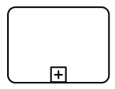

3. **End events**show what are the results/outcomes of the process, so that you know its scope (e.g. do we assume our process ends when the goods are shipped to customer or do we wait till the payment is received). Again - this is NOT what you do, but rather summary of what was achieved in a process.

This is very important because **if you name your start and end events properly**, your audience will not even need to see the process content in detail to **know the scope** and general vision of the process and how can it flow (more on this topic in the following section). It allows you to avoid gaps or white space in your processes.

You should name them using the **noun + verb (in passive voice)** convention e.g. **Goods shipped**.

End events are always**circles with single thick border.**



4. **Sequence Flow**shows you how does the process flow: starting at the start event and finishing at the end event.

They are arrows drawn with **solid line**and with a **solid arrowhead**.

https://www.filepicker.io/api/file/DjnvgilTpGW7eTEW9nv3

**Side note:** your diagrams should be readable for your target audience.

If you create diagrams to communicate the processes to the business users and get feedback from them you should not have more than 30 objects in your diagram.**Ideally aim for 5-9 tasks or Sub-Processes and no more than 30 objects in total.**

If you create more technical diagrams for IT professionals they may accept more details, but always try to make your diagram as easy to understand as possible.

**[Comment]**

Did you specify all the important steps AND did not flood the diagram with unnecessary details (e.g. preparing breakfast is a nice candidate for a subprocess)?

Are there 5-9 activities or 20+? Can you grasp the vision of the process in less than one minute?

Does your process diagram show clearly how did your process end? Was it rather "Home left" (assuming you leave home for work) or "Door locked"? :)

**[Key takeaways] Chapter 2: Gateways**

**Your key takeaways:**

If your process does not flow in a simple sequence you need to show what are the alternative ways of operating and which activities are done in parallel. BPMN allows many ways to do it, but most robust and easy to understand way involves **gateways**.

There are 3 types of gateways you need to know (plus some more you do not need to worry about too much):

1. **Exclusive Gateways** show where does your process split into mutually exclusive paths. This is NOT activity of decision making (this should happen before the gateway), only handling the results.

The most popular naming convention is to name the exclusive gateway using a question (e.g. **Offer accepted?**) and provide answers on the sequence flows outgoing from this gateway.

Exclusive gateways are shown either as**diamonds**with no marker or**diamonds with X marker.**It means the same, but you should stick to one.

or

If you use the exclusive gateways that lead to different process results please make sure to name your end events properly (e.g. Order sent for the happy path and Lost lead documented for the path where customer did not order).

2. **Parallel Gateways**show where you begin doing things in parallel. It does not mean that the activities need to take place at the same time (however it is usually the desired behavior), but rather that **all active paths** (that started at the parallel gateway) **must finish before the process can continue**.

For this purpose, you always use one gateway to **split** and one to **merge the process paths.**

Parallel gateways usually do not need to have (visible and) meaningful names.

They are visualized as **diamonds with + marker.**

**https://www.filepicker.io/api/file/6W9CGHCOSgmH1THIZjnb**

3. **Inclusive Gateways** allow you to document more complicated situations when **one or more paths can be selected** depending on their conditions. Again - **you need to merge** the paths you started.

Since you need to have the conditions on the sequence flows you should name the inclusive gateways in a similar way like exclusive gateways so in a form of question.

They are visualized as **diamonds with circle inside.**



4. Default Sequence Flow

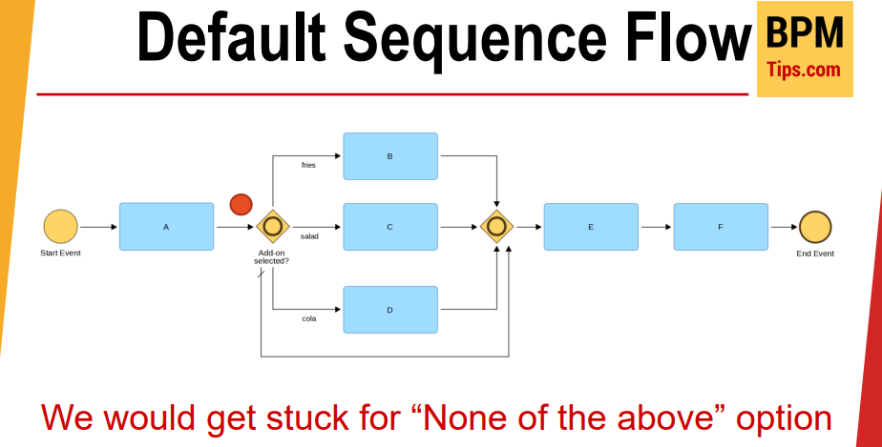

* Gateway를 통해 나눠진 각각의 Token이 다시 모두 합쳐져야 다음 과정으로 넘어갈 수 있다.
* 단, 해당 조건을 만족하지 못했을 경우, Default sequence flow를 통해 막히는 경우를 방지할 수 있다.

**[Key takeaways] Chapter 3: Object types**

**Your key takeaways:**

BPMN allows you to make your diagrams more expressive thanks to the various categorizations of your objects. Some of them are just attributes sitting inside the objects (we will not cover them), but some also influence the looks of the objects which is very useful.

Why? Because they immediately give your end users more context for your diagram. They do not need to read the object names, only take a quick glance at the markers.

**Below you can find most useful types of the following object types.** I show you only those, which I checked during my BPMN trainings with various participants and over 90% guessed correctly their meaning before I explained anything. This is useful, because your end users should also guess the meaning which will make them feel competent and more willing to work with your diagrams.

**1. Tasks**

Task type **markers are always shown in top left corner.**

**a) Manual Task**

If you want to show that some **work is being done with no IT support** this task type is your friend. It has so many uses: finding places for the process improvement, checking automation opportunities, making sure this process step is compliant...

**Marker**for this type**is a hand** (as you would expect from a manual task)



**b) User Task**

Those are the tasks **done by a person with an IT support** (i.e. using some application). Ideally, this is some kind of a workflow solution, where the tasks are assigned to users and appear on their task lists.

**Marker**for this type**is a human figure** (just like the default account picture in nearly all recent software tools)



**c) Service Task**

Those are the places where **work is done automatically by**some **application**(e.g. ERP system) or a **service.**

**Marker**for this type shows two **cogwheels** or **gears** (like in a clock).



**2. Sub-Processes**

**a) Embedded Sub-Process**

Good news - you already know them. They are used to **hide the complexity** from your main diagram into a "child" sub-model.

They are the **rounded rectangles with + marker at the bottom.**



**b) Call Activity**

OK - this one was not among the most intuitive ones and needs some explanation, but is super useful. It allows you to mark that you refer to some **standard way of doing work**, which is not only part of your diagram, but something more widely used - **like a shared service**.

Think for example about procurement, invoicing, handling outgoing letters - they are all called by many processes, are (possibly) executed by different teams of people and require more formal communication (you should not expect that your colleagues will prepare a tender on a basis of a brief conversation in an elevator - right?).

It looks also has **plus marker**, but is drawn with a **thick border**.

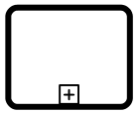

**3. Start events**

As you recall, start events show you what can make your process start. Types of the start events are actually **types of triggers.**

All the markers are shown inside the start object circle.

**a) Message Start Event**

If your process starts upon receipt of an e-mail, phone call or after potential customer asks you for an offer - pick this one. It shows that **process starts when we** **receive some directed message**.

It uses the **envelope marker** (no explanation is needed I guess).

https://www.filepicker.io/api/file/xBmJBYPdQZmYfSUM5IAr

**b) Timer Start Event**

This one is used when your **process starts on a given moment of time** (e.g. 2 days before quarter ends or every Friday at 6 PM).

It uses the **clock marker** (again no problem with remembering).

https://www.filepicker.io/api/file/V8Y4DMkyRGAmr4LMhCDd

**c) Conditional Start Event**

If your **process starts when some conditions are met**(e.g. stock level drops below minimum) you should select this one.

It uses the **lined paper marker**(personally I like to think this is a checklist)

https://www.filepicker.io/api/file/0kYcG6DhS0SnodjgDTSw

**[Key takeaways] Chapter 4 : Participants and collaboration**

**Your key takeaways:**

1) **Pools** represent the **process participants**. Those can be organizations or units - it depends on your perspective (participant has full control over the process inside its own pool).

Pools can either have process inside or be empty placeholders (**black-box pools**).

They are rectangles with a label (and dividing line).



2) **Lanes**allow you to divide your pools to better organize their content (e.g. to show which role does what).

They are rectangles within a pool.



3. **Message Flows**allow you to show the collaboration between the process participants.

Those are arrows drawn with **dashed line**.

https://www.filepicker.io/api/file/VYjtRlx4SOuDVG0cSiW1

**Important: using flows with pools**

**Sequence Flows are allowed only within pools**. Just like you cannot swim outside your swimming pool, you cannot have sequence flow that traverses pool boundary. In each pool sequence flow should flow from the start to the end without gaps.

**[Key takeaways] Data modeling**

**Your key takeaways:**

1) **Data Association** allow you to show how does the data flow through a process (within a pool).

https://www.filepicker.io/api/file/ma8CAtvKSVWJD5oCgiBl

2) **Data Object** represents data used inside the process (e.g. documents) which is **accessible as long as the process instance is active**.

Apart from the name you can also have **data state in square brackets e.g. Invoice [accepted].**

https://www.filepicker.io/api/file/n7cmw1f2TG8MXKLwNsqc

3. **Data Store**allows you to access and update the stored information outside the scope of the process instance (**e.g. in IT systems**).

https://www.filepicker.io/api/file/mBiN3JtBTUOVETPG5h3Z

Do you want to see real life example of Data Objects usage?

This is what we covered in 2018 edition of BPMN Model Iterchange Working Group (BPMN MIWG) demonstration (which took place during OMG Technical Meeting in Seattle).

**[Key takeaways] Chapter 5 : Artifacts**

**Your key takeaways:**

1) **Artifacts** allow you to show additional information about the process which do not influence the process flow (they cannot be parts of the sequence flow).

2) **Text Annotation** allows you to show some additional info about the process or a process element. In this case it is attached using the **Association**(dotted line, optionally with an arrow if we want to show direction).

https://www.filepicker.io/api/file/jS3rbIiITtumDhKvnjtx

3. **Group**is useful if you want to highlight some categorization inside your process e.g. show which process steps are planned for automation.



**[Key takeaways] Chapter 6 : Formal names of BPMN elements**

Do you recall the introduction where I told you that I will apply the Pareto principle and show you only the useful elements?

So far I wanted to help you understand the most useful BPMN elements without overburdening you with some strange names, but if you are preparing for the job interview they may care less about your practical knowledge than about answering the questions. **So - below you can the official names for what we were discussing.**

**There are 5 basic categories of elements in BPMN:**

1. Flow Objects
2. Connecting Objects
3. Swimlanes
4. Data
5. Artifacts

**Flow Objects**are:

1. **Events**(we covered the **Start and End Events** with the basic types, there can be also **Intermediate Events** that take place during the process - kind of milestones; you will instantly recognize them as half way between start and end events as they are circles with double thin border)
2. **Activities**(this is just a category name for the **Tasks** and **Sub-Processes**)
3. **Gateways**(we covered the most common types)

**Connecting Objects**are:

1. **Sequence Flows** (please note BPMN allows some additional markers on the Sequence Flows we did not cover)
2. **Message Flows**
3. **Associations**
4. **Data Associations**

**Swimlanes**are:

1. **Pools**
2. **Lanes**

**Data** elements are:

1. **Data Objects** (plus their 2 specific types we did not cover - see below)
2. **Data Inputs**
3. **Data Outputs**
4. **Data Stores**

**Artifacts**are:

1. **Text Annotations**
2. **Groups**

PS. Below you can find a graphic with a summary of those categories. Thanks for inspiration Sampath!

